**Comparative Performance Analysis of Jaguar and Panther:**

**Data Analysis**

Year 2025 Data Analysis Report

*January, 2025*

***Prepared by,***

**Nikki Grace D. Magdali**

**BSCpE 2A**

**Report Highlights**

* The **Jaguar** dataset shows a higher mean, median, and mode compared to the **Panther** dataset, suggesting that the values for Jaguars tend to be higher on average.
* **Jaguar** has higher variance and standard deviation, indicating greater spread and variability in the dataset.
* The **Panther** dataset has much lower standard deviation and coefficient variation, signifying that the values are more **consistent** and **less spread out**.

**Understanding Data Spread and Stability for Jaguar and Panther Resistor Measurements**

**Analyzing the Performance of Jaguar**

* As shown in the Figure 1, Jaguar dataset exhibits **wide range** of values from 790 to 1840 ohms, which indicates significant variability in the measurement. In addition, Jaguar’s range is 1050

Figure 1: Jaguar’s Dataset

Jaguar =[997, 1153, 920, 1074, 1013, 960, 890, 910, 944, 1065, 1083, 1820, 859, 1043, 1710,933, 790, 999, 1028, 976, 1015, 932, 957, 936, 977, 1037, 997, 1730, 1046, 1840]

Range = max – min

Range = 1840 – 790

**Range = 1050**

* The calculated **mean** value is **1087**.**80** ohms as shown in Figure 2.

Figure 2: Jaguar’s Mean Calculation

Mean Formula: $$\bar{x}= \frac{\sum{x}}{N}$$

x̄ = (997+ 1153+ 920+ 1074+ 1013+ 960+ 890+ 910+ 944+ 1065+ 1083+ 1820+ 859+ 1043+ 1710+933+790+ 999+ 1028+ 976+ 1015+ 932+ 957+ 936+ 977+ 1037+ 997+ 1730+ 1046,+1840) / 30

x̄ = $\frac{32,634}{30}$

**x̄ = 1,087.80**

* The **median** of the Jaguar dataset is **998 (Figure 3)**, which is slightly lower than the mean, indicating that the data has a positive skew with some higher readings influencing the average.

Figure 3: Jaguar’s Median Calculation

Mean Formula: $$median= \frac{(n+1)}{2}$$

m = $\frac{30+1}{2}$

m = 15.5th place

m = 997 + 999

**m = 998**

* The **mode** is **997** **ohms** which is relatively close to the calculated median.

Figure 4: Arranged dataset from smallest to largest

Jaguar = [790,859,890,910,920,932,933,936,944,957,960,976,977,997,997,999,1013,1015,1028,1037,1043,1046,1065,1074,1083,1153,1710,1730,1820,1840]

**mode = 997 ohms**

* The **Variance** is **80749**.**82** which means it has great amount of variation or dispersion.

Figure 5: Variance Calculation

var = √ $\frac{\sum{(x-\bar{x})^2}}{n-1}$

= $(x-\bar{x})^2$

(997-1087.80)2= 1

(1153-1087.80)2=24025

(920-1087.80) 2= 6084

(1074-1087.80)2= 5776

(1820-1087.80) 2= 675684

(859-1087.80) 2=19321

(1043-1087.80) 2=2025

(1710-1087.80) 2=506944

(933-1087.80) 2=4225

(790-1087.80) 2=43264

(999-1087.80) 2=1

(1013-1087.80) 2=225

(960-1087.80) 2=1444

(890-1087.80) 2=11664

(910-1087.80) 2=7744

(944-1087.80) 2=2916

(1065-1087.80) 2=4489

(1083-1087.80) 2=7225

(1037-1087.80) 2=1521

(997-1087.80) 2=1

(1730-1087.80) 2=535824

(1046-1087.80) 2=2304

(1840-1087.80) 2=708964

(1028-1087.80) 2=900

(976-1087.80) 2=484

(1015-1087.80) 2=289

(932-1087.80) 2=4356

(957-1087.80) 2=1681

(936-1087.80) 2=3844

(977-1087.80) 2=441

=

= 1.890954695x1011

S2 =

s = √

**s =80749.82**

* The **standard** **deviation** based on calculation is **284.17**

Figure 6: Standard Deviation Calculation

**o =**√**80749.82**

**o = 284.17**

* The **coefficient of variation** is **0.26**

Figure 7: C.V Calculation

cv = $\frac{o}{u}$

cv = $\frac{284.17}{1087.80}$

**cv = 0.26**

**Summary**

Since the mean is noticeably higher than the median this suggests that presence of a few larger values (outliers) pulling the average upward. On the other hand, the median being lower than the mean suggest that the data is right-skewed, where there are some higher values disproportionately affecting the mean. Additionally, the calculated data also indicate that the dataset value is clustered very closely around the median range. Lastly, it suggests significant variability or spread in data and indicates moderate relative variability (CV at 0.26), implying that while there is some variability it is not excessively high.

**Analyzing the Performance of Panther**

* As shown in Figure 8, the dataset also exhibit wide range of values from 590 to 1710 ohms. In addition, Panther’s range is **1120**.

Figure 8: Panther Dataset

**Panther** = [590,790,891,907,934,935,942,946,960,969,975,978,982,986,990,999,1007,1011,1026,1026,1035,1038,1041,1073,1076,1078,1083,1090,1092,1710]

Range = max – min

Range = 1710-590

**Range = 1120**

* The calculated **mean** value is **1005.33** as shown below. This indicate that the data is right-skewed, meaning there few higher values that pulls the average upwards.

Figure 9: Panther Dataset

Mean Formula: $$\bar{x}= \frac{\sum{x}}{N}$$

**Panther** = [ 590+790+891+907+934+935+942+946+960+969+975+978+982+986+990+999+1007+1011+1026+1026+1035+1038+1041+1073+1076+1078+1083+1090+1092+1710 ]

x̄ = 30,160 / 30

**x̄ = 1005.33**

* The calculated median on the other hand is 994.50

Figure 10: Panther’s Median Calculation

Mean Formula: $$median= \frac{(n+1)}{2}$$

m = $\frac{30+1}{2}$

m = 15.5th place

m = 990 + 999

**m = 994.5**

* Panther’s mode is **1026**. In this given data, it shows that the mode is higher than the median, further emphasizing this positive skewness.

Figure 11: Panther Dataset

**Panther** = [ 590+790+891+907+934+935+942+946+960+969+975+978+982+986+990+999+1007+1011+**1026+1026**+1035+1038+1041+1073+1076+1078+1083+1090+1092+1710 ]

**Mode = 1026 ohms**

* The calculated **variance** is **27,642.85**.

Figure 12: Variance Calculation

var = √ $\frac{\sum{(x-\bar{x})^2}}{n-1}$

= $(x-\bar{x})^2$

(590-1005.33)2= 172,499

(790-1005.33)2=46,367

(891-1005.33) 2= 13071

(907-1005.33)2= 9668.79

(1078-1005.33)2= 5280.92

(1083-1005.33)2= 6032.63

(1090-1005.33)2= 7169

(1092-1005.33)2= 7511.69

(1710-1005.33)2=

496559.81

(1026-1005.33)2= 427.25

(1026-1005.33)2= 427.25

(1035-1005.33)2= 880.31

(1038-1005.33)2= 1067.33

(1041-1005.33)2= 1272.35

(1073-1005.33)2= 4579.23

(1076-1005.33)2= 4994.25

(978-1005.33)2= 746.93

(982-1005.33)2= 544.29

(986-1005.33)2= 373.65

(990-1005.33)2= 235

(999-1005.33)2= 40.07

(1007-1005.33)2= 2.79

(1011-1005.33)2= 32.15

(934-1005.33)2= 5087.97

(935-1005.33)2= 4946.31

(942-1005.33)2= 4010.69

(946-1005.33)2= 3520.05

(960-1005.33)2= 2054.81

(969-1005.33)2= 1319.87

(975-1005.33)2= 919.91

=

= 22159687527.55

S2 =

s = √

**s =27,642.85**

* The **standard deviation** based on calculation is **166.26**.

Figure 13: Standard Deviation Calculation

**o =**√**27,642.85**

**o = 166.26**

* The **coefficient of variation** is **0.17**.

Figure 14: C.V Calculation

cv = $\frac{o}{u}$

cv = $\frac{166.26}{1005.33}$

**cv = 0.17**

**Summary**

Since the mean is slightly higher than the median, it indicates the presence of a few larger values (outliers) pulling the average upward. This right-skewed distribution suggests that higher values have a modest influence on the mean. The data is relatively consistent, with values closely clustered around the median. The variability is moderate (CV at 0.17), indicating stable performance with less spread compared to Jaguar.

**Comparative Analysis of Jaguar and Panther Data**

|  |  |  |
| --- | --- | --- |
| **Metric** | **Jaguar** | **Panther** |
| |  |  | | --- | --- | | Range (ohms) |  | | 1050 | |  | | --- | | 1120 | |
| |  |  | | --- | --- | | Mean (ohms) | 1005.33 | | |  | | --- | | 1087.80 | | |  | | --- | | 1005.33 | |
| |  |  |  | | --- | --- | --- | | Median (ohms) |  | 994.50 | | 998 | |  | | --- | | 994.50 | |
| |  |  |  | | --- | --- | --- | | Mode (ohms) |  |  | | 997 | 1026 |
| |  |  | | --- | --- | | Variance |  | | 80,749.82 | 27,642.85 |
| |  |  |  | | --- | --- | --- | | Standard Deviation |  |  | | 284.17 | 166.26 |
| |  | | --- | | Coefficient of Var. | | 0.26 | |  | | --- | | 0.17 | |

**Analysis**

1. Mean and Median

* Both datasets are right-skewed as shown by their mean and higher than their medians.
* Additionally, Jaguar has higher mean which indicates larger data value compared to Panther.

1. Variability

* Jaguar’s data showed significant greater variability and standard deviation compare to Panther.
* In addition, the coefficient of variation also highlights the difference between Jaguar (0.26) and Panther (0.17).

1. Range

* In terms of range, Panther has slightly higher range (1120) compare to Jaguar (1050).

1. Skewness

* Both datasets are right-skewed but in the calculated data, Pather’s mean and median are closer compare to Jaguar. This means that there is less skewness in Panther’s data.

**Hypothesis**

Based on the given data, Panther shows better performance overall, especially it has lower variability and it is less influenced by higher values (in the dataset). On the other hand, Jaguar’s performance, while it has higher ohms values, exhibits significant variability which makes it less predictable in practical applications.

APPENDIX A

Tables and Figures

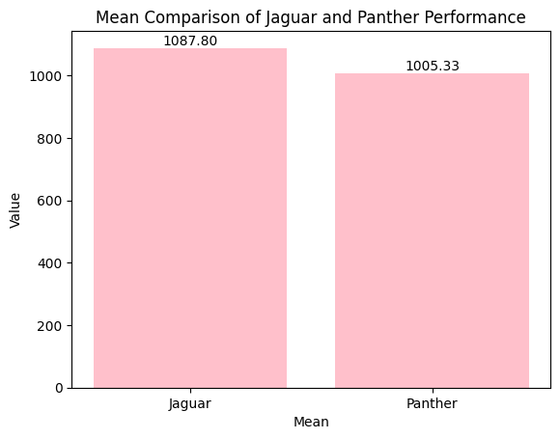

*Figure 15*. Mean Comparison

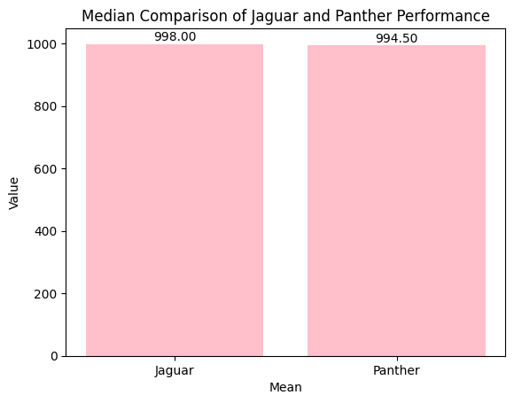

*Figure 16.* Median Comparison

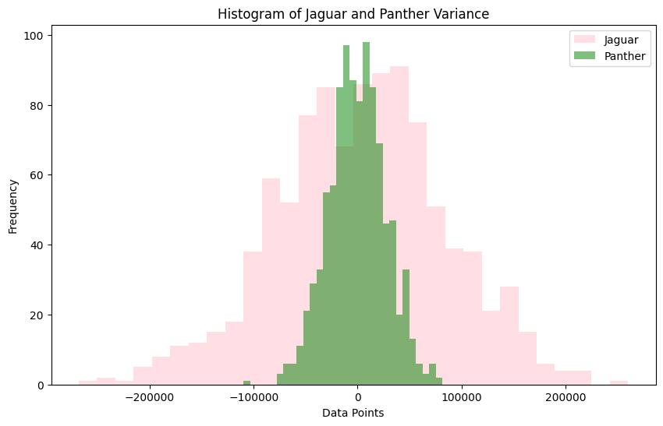

*Figure 17*. Variance Comparison using Histogram

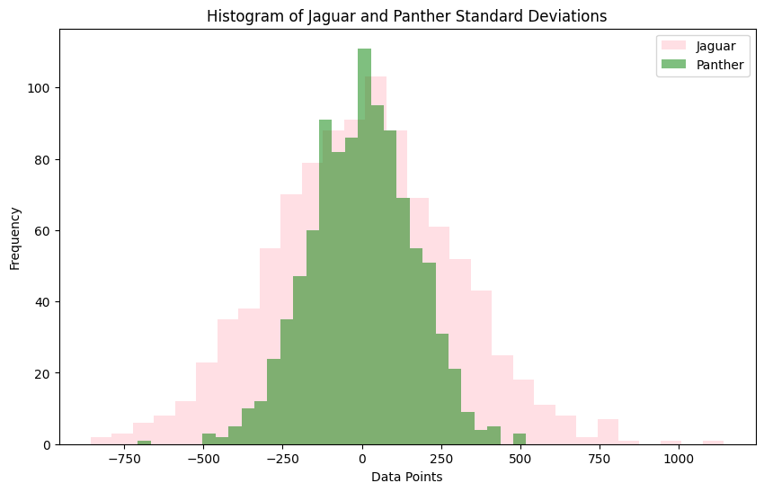

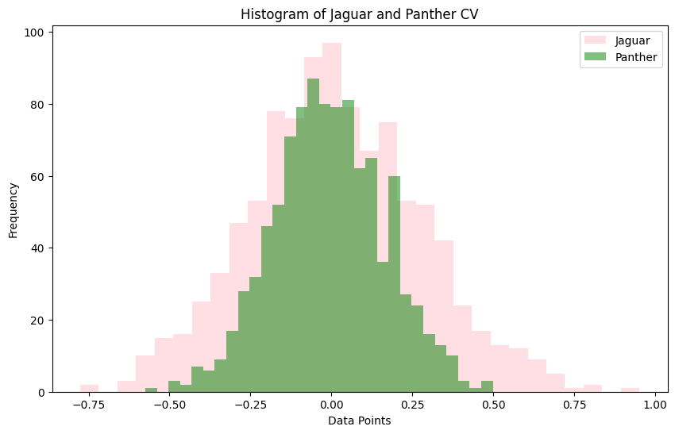 *Figure 18*. Standard Deviation Comparison using Histogram

*Figure 19*. Coefficient of Variation using Histogram